Edit index.html
C:\code\gradle\firstWebApp\firstWebApp\src\main\webapp
<!DOCTYPE html>
<html>
<title>Online HTML Editor</title>
<head>
</head>
<body>
<h1>Welcome to CDAC ACTS</h1>
<a href="coupon">Get Coupon</a>
<form method = "post" action = "discount">
Coupon Code: <input type = "text" name = "coupon">
<input type = "submit" value = "Get Discount">
</form>
</body>
</html>

—------------------------------------------------------------------------------------

Create File DiscountServelet.java inside
C:\code\gradle\firstWebApp\firstWebApp\src\main\java\com\cdac\ditiss

package com.cdac.ditiss;

import java.io.IOException;
import java.io.PrintWriter;
import javax.servlet.ServletException;
import javax.servlet.annotation.WebServlet;
import javax.servlet.http.HttpServlet;
import javax.servlet.http.HttpServletRequest;
import javax.servlet.http.HttpServletResponse;

@WebServlet("/discount")
public class DiscountServlet extends HttpServlet {
protected void doPost(HttpServletRequest request, HttpServletResponse response)
throws ServletException, IOException {
String coupon = request.getParameter("coupon");
request.setAttribute("discount","Discount for coupon " + coupon + " is 50%");
request.getRequestDispatcher("response.jsp").forward(request, response);

}
}

—------------------------------------------------------------------------------------

Create a response.jsp file inside
C:\code\gradle\firstWebApp\firstWebApp\src\main\webapp
<%@ page contentType = "text/html" %>
<!DOCTYPE html>
<html>
<head>
<title>Discount Page</title>
</head>
<body>
<h3>${discount}</h3>
</body>
</html>

—------------------------------------------------------------------------------------

Go to C:\code\gradle\firstWebApp and open cmd
C:\code\gradle\firstWebApp> gradle war
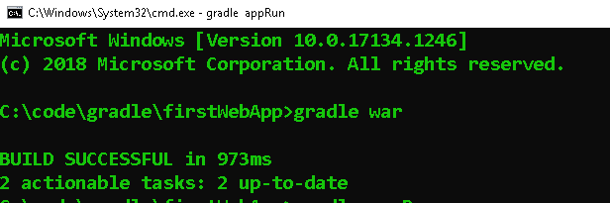

C:\code\gradle\firstWebApp> gradle appRun
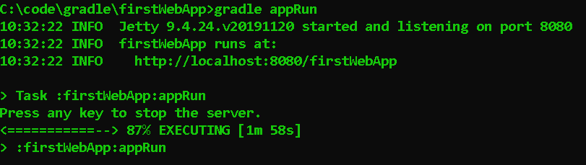

Copy link and paste in browser
http://localhost:8080/firstWebApp
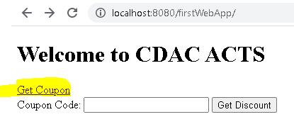
Copy code SUPERSALE
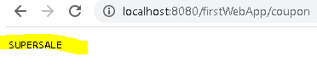
Go back and paste coupon code SUPERSALE
⇒click on Get Discount
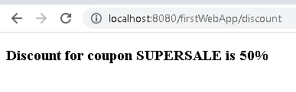
-x-x-x–x-x-x-x-x-x-x-x-x-x-x-x-x–x-x-x-x-x-x-x-x-x-x-x-x-x-x-x-x-x-
If Else Condition (Multiple coupon codes)

SUPERSALE MAHASALE FASTSALE

—------------------------------------------------------------------------
Edit DiscountServlet.java which is present in
C:\code\gradle\firstWebApp\firstWebApp\src\main\java\com\cdac\ditiss
package com.cdac.ditiss;

import java.io.IOException;
import java.io.PrintWriter;
import javax.servlet.ServletException;
import javax.servlet.annotation.WebServlet;
import javax.servlet.http.HttpServlet;
import javax.servlet.http.HttpServletRequest;
import javax.servlet.http.HttpServletResponse;

@WebServlet("/discount")
public class DiscountServlet extends HttpServlet {
protected void doPost(HttpServletRequest request, HttpServletResponse response)
throws ServletException, IOException {
String coupon = request.getParameter("coupon");
int discountValue = 0;

if (coupon.equals ("SUPERSALE"))
discountValue = 10;
else if (coupon.equals ("MAHASALE"))
discountValue = 20;
else if (coupon.equals ("FASTSALE"))
discountValue = 30;
request.setAttribute("discount","Discount for coupon " + coupon + " is " + discountValue + "%");
request.getRequestDispatcher("response.jsp").forward(request, response);

}
}

—------------------------------------------------------------------------
Edit CouponServlet.java which is present in
C:\code\gradle\firstWebApp\firstWebApp\src\main\java\com\cdac\ditiss

package com.cdac.ditiss;

import java.io.IOException;
import java.io.PrintWriter;
import javax.servlet.ServletException;
import javax.servlet.annotation.WebServlet;
import javax.servlet.http.HttpServlet;
import javax.servlet.http.HttpServletRequest;
import javax.servlet.http.HttpServletResponse;

@WebServlet("/coupon")
public class CouponServlet extends HttpServlet {
protected void doGet(HttpServletRequest request, HttpServletResponse response)
throws ServletException, IOException {
response.getWriter().print("SUPERSALE MAHASALE FASTSALE");
}
}

- Run same cmds> gradle war> gradle appRun
- Open through the link and copy paste same codes and get discount.
—--------------------------------------------------------------------------------------

-x-x-x–x-x-x-x-x-x-x-x-x-x-x-x-x–x-x-x-x-x-x-x-x-x-x-x-x-x-x-x-x-x-

—--------------------------------------------------------------------------------------
MICROSERVICES
—--------------------------------------------------------------------------------------

Software designed to support Inter Protocols, Machine to machine interaction over a network.

 | Web services (Old) | Micro Services  (New)
Message exchange using | XML | JSON
Protocol | SOAP | REST
Implementation | Complex | Very easy
Underlying mechanism | HTTP GET/POST | HTTP GET/POST
—--------------------------------------------------------------------------------------

Microservice definition

- A microservice is an independently releasable service that is modeled around a business domain
- Example

E-commerce system ⇒
                - Inventory microservice
                - Order management microservice
                - Shipping microservice
—--------------------------------------------------------------------------------------
https://start.spring.io/
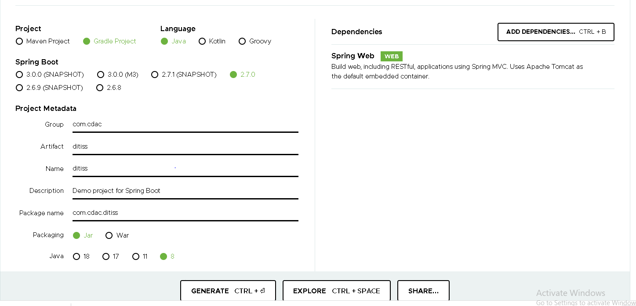

- Unzip downloaded file and paste it in C drive
- Open cmd in ditiss folder
- Go to C:\ditiss Edit build.gradle and save it strictly.
plugins {
id 'org.springframework.boot' version '2.7.0'
id 'io.spring.dependency-management' version '1.0.11.RELEASE'
id 'java'
id 'application'
}

group = 'com.cdac'
version = '0.0.1-SNAPSHOT'
sourceCompatibility = '1.8'

repositories {
mavenCentral()
}

dependencies {
implementation 'org.springframework.boot:spring-boot-starter-web'
testImplementation 'org.springframework.boot:spring-boot-starter-test'
}

tasks.named('test') {
useJUnitPlatform()
}

application {
//Define the main class for the application.
mainClass = 'com.cdac.ditiss.DitissApplication'
}

Go to ditiss folder open cmd >gradle compileJava
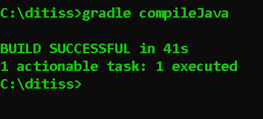

Go to ditiss folder open cmd >gradle run

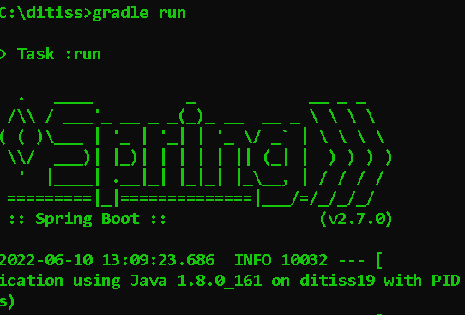

Open Chrome
http://localhost:8080/
